Prepared by: Sayed Ahmed
Individual Testing

1. Assignment & Accountability
Contributor | Sayed Ahmed
Assessment focus | Cross-Site Scripting (XSS)
Week / reporting period | Week 1 / exact dates not provided
Target / environment | OWASP Juice Shop — local instance
Testing platform | Juice Shop
Tools | Firefox; Burp Suite (optional, as recorded in source notes)

2. Objective, Scope & Preconditions
The objective was to exercise the XSS-related challenges in the local OWASP Juice Shop training application, observe whether supplied input resulted in browser-side JavaScript execution, and verify challenge completion through the application's Score Board where evidence was available.
Scope recorded in the source material: the DOM-Based XSS challenge, the Bonus Payload challenge, and the Reflected XSS challenge workflow. The search field was used for payload submission. A successful order was also placed with test data to reach the Track Orders workflow; this is recorded as preparation, not as a confirmed XSS finding.
Preconditions: the Juice Shop instance was running locally and accessible through Firefox. The source notes identify Kali Linux as the environment. No application version, test-account details, or exact testing dates were supplied; these are therefore not assumed in this report.

3. Test Log
Date | Asset / Challenge | Test case | Outcome | Evidence ID
Not recorded | DOM-Based XSS / search field | Submitted the recorded iframe-based payload. | JavaScript alert observed; Score Board showed the challenge as solved. | EV-01 to EV-03
Not recorded | Bonus Payload | Used the challenge-provided bonus iframe payload and checked the result. | Success notification recorded; challenge marked solved in source notes. | EV-04 to EV-05
Not recorded | Reflected XSS | Submitted an iframe payload in the search field and reviewed the challenge state. | Alert observed, but challenge completion and Reflected XSS classification remain unverified. | EV-06 to EV-07
Not recorded | Track Orders preparation | Added a product and completed checkout using test data. | Order confirmation page reached; Track Orders testing was the next planned step. | EV-08

4. Finding Records

Finding XSS-01 — DOM-Based XSS Challenge Execution
Finding ID / Title | XSS-01 — DOM-Based XSS
Affected component | Juice Shop search interface / client-side DOM handling
Method / account role | Browser-based input submission; account role not documented
Severity / CVSS | Not rated — the supplied evidence is insufficient for a defensible severity or CVSS score
Status | Challenge marked solved in the application's Score Board

4.1 Summary
A crafted iframe-based input was submitted through the Juice Shop search field. The browser displayed a JavaScript alert containing “xss”, demonstrating that the submitted input reached an executable browser context in this challenge. The Score Board screenshot records the DOM XSS challenge as solved.

4.2 Preconditions
The local Juice Shop application was available in Firefox, and the search field accepted the test input.

4.3 Reproduction Steps
- Open the local OWASP Juice Shop instance in Firefox.
- Locate the search field in the application interface.
- Submit the iframe-based payload recorded in the source notes.
- Observe the JavaScript alert displayed by the browser.
- Open the Score Board and verify that the DOM XSS challenge is marked as solved.

4.4 Expected vs. Actual Result
Expected: user-controlled search input should be handled as data and must not trigger script execution.
Actual: a JavaScript alert appeared after submission, and the Score Board showed the DOM XSS challenge as solved.

4.5 Impact & Limitations
The evidence demonstrates script execution in the intentionally vulnerable training application. In a real application, a comparable DOM XSS weakness may allow attacker-controlled script execution in a victim's browser under the application's origin. The supplied evidence does not establish access to session tokens, account data, or any impact beyond the demonstrated alert.

4.6 Remediation Recommendation
- Treat search input as untrusted data and avoid inserting it into executable HTML contexts.
- Prefer safe DOM APIs such as textContent and createElement instead of unsafe HTML sinks such as innerHTML.
- Where HTML rendering is required, apply context-appropriate output encoding and a well-maintained HTML sanitizer.
- Use a restrictive Content Security Policy as defense in depth; do not treat CSP as a replacement for safe DOM handling.

Finding XSS-02 — Bonus Payload Challenge
Finding ID / Title | XSS-02 — Bonus Payload Challenge Completion
Affected component | DOM XSS challenge workflow in OWASP Juice Shop
Method / account role | Browser-based challenge interaction; account role not documented
Severity / CVSS | Not applicable as a separate vulnerability rating — this is recorded as a solved training challenge
Status | Solved, according to the source notes

4.1 Summary
The source notes state that the bonus iframe payload supplied by the challenge was used within the DOM XSS challenge workflow. A success notification was recorded, and the Bonus Payload challenge was marked as solved.

4.2 Preconditions
The DOM XSS challenge was accessible in the local Juice Shop instance.

4.3 Reproduction Steps
- Open the DOM XSS challenge in Juice Shop.
- Use the bonus iframe payload displayed by the challenge.
- Submit the payload through the challenge workflow.
- Check the application response for the success notification.

4.4 Expected vs. Actual Result
Expected: the challenge should accept the supplied bonus payload when used as intended.
Actual: the source notes record a success notification and a solved challenge status.

4.5 Impact & Limitations
This record documents completion of a deliberately vulnerable training challenge. It should not be interpreted as a separate production vulnerability finding beyond the DOM XSS behavior already documented in XSS-01. The exact bonus payload string is not legible in the exported source and has not been reconstructed.

4.6 Remediation Recommendation
Apply the same safe DOM-handling controls described in XSS-01. Do not insert untrusted markup into the page without context-aware validation, sanitization, and safe rendering.

Observation XSS-03 — Reflected XSS Challenge (Verification Pending)
Observation ID / Title | XSS-03 — Reflected XSS Challenge Investigation
Affected component | Juice Shop search workflow / challenge page
Method / account role | Browser-based payload submission; account role not documented
Severity / CVSS | Not assigned — vulnerability class and impact are not sufficiently verified
Status | Pending verification; challenge recorded as not solved

4.1 Summary
The source notes record that an iframe payload was entered in the search field and a JavaScript alert displaying “xss” appeared. However, the specific Reflected XSS challenge status still required verification. The current evidence does not establish that the input was reflected by the server into the HTTP response; therefore, this report treats the event as an observed JavaScript execution during the investigation, not as a confirmed Reflected XSS finding.

4.2 Preconditions
The Reflected XSS challenge was visible in the Juice Shop challenge list and the search workflow was accessible.

4.3 Recorded Test Steps
- Open the Reflected XSS challenge workflow.
- Enter the iframe payload in the search field, as recorded in the source notes.
- Observe the JavaScript alert displayed by the browser.
- Re-check the challenge state in the Score Board; the source notes record the challenge as not solved / requiring verification.

4.4 Expected vs. Actual Result
Expected: the challenge's specific reflected-input condition should be demonstrated and its completion status verified.
Actual: a JavaScript alert was observed, but the challenge status and the server-side reflection path were not confirmed.

4.5 Impact & Limitations
The alert alone confirms browser-side JavaScript execution for the tested input, but it does not distinguish Reflected XSS from DOM-based execution. A request/response capture or equivalent evidence showing the input reflected into the response is needed before classifying this as Reflected XSS.

4.6 Recommended Next Verification
- Capture the exact request generated by the search action using Burp Suite Proxy or browser developer tools.
- Inspect the corresponding response and determine whether the submitted value is reflected by the server.
- Trace the value into the DOM and identify the execution sink; distinguish server reflection from client-side DOM processing.
- Verify the Reflected XSS challenge's solved state in the Score Board before closing the observation.

5. Additional Test Preparation — Track Orders
The source material records that a product was added to the basket, checkout was completed using test data, and an order confirmation page was reached. The Track Orders link was then located for the next testing step. No Track Orders vulnerability result is documented in this Week 1 material.

6. Evidence Register
Evidence ID | Filename | Description
EV-01 | EV-01-Juice-Shop-Target.png | OWASP Juice Shop running in the local browser.
EV-02 | EV-02-DOM-XSS-Alert.png | JavaScript alert displayed after submitting the search-field payload.
EV-03 | EV-03-Scoreboard-DOM-XSS.png | Score Board showing the DOM XSS challenge as solved.
EV-04 | EV-04-Reflected-XSS-Search-Page.png | Search results page and challenge context shown during Reflected XSS testing.
EV-05 | EV-05-Bonus-Payload-Challenge.png | Bonus Payload challenge card and its displayed challenge details.
EV-06 | EV-06-Reflected-XSS-Challenge-Status.png | Score Board view showing the Reflected XSS challenge status.
EV-07 | EV-07-Reflected-XSS-Alert.png | JavaScript alert observed during the Reflected XSS investigation; challenge completion remains unverified.
EV-08 | EV-08-Order-Confirmation.png | Order confirmation page reached during preparation for Track Orders testing.
Evidence handling note: the screenshots were extracted from the supplied Week 1 PDF without altering their content. The report embeds the evidence for convenient review; the original PNG files are also provided separately in the accompanying Evidence folder/package.

7. Assessment Summary & Outstanding Items
- DOM-Based XSS challenge: solved; browser alert and Score Board evidence are present.
- Bonus Payload challenge: solved according to the source notes; success evidence is present.
- Reflected XSS: JavaScript alert observed, but the specific challenge and reflected-input behavior remain unverified.
- Track Orders: checkout completed and order confirmation captured; the next testing step is not documented as completed.
Information to complete before final academic submission: Member ID and exact Week 1 reporting dates. These fields were not present in the supplied source material and have intentionally been left unspecified.

Appendix A — Screenshot Evidence
The following screenshots are reproduced from the supplied Week 1 export. Each item is mapped to the Evidence Register.
EV-01 — OWASP Juice Shop running in the local browser.
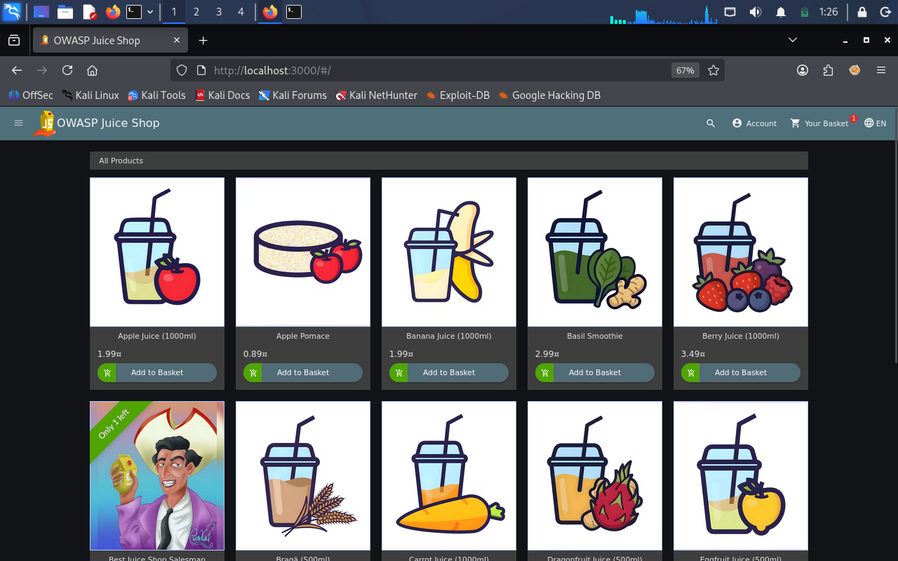
Evidence file: Evidence/EV-01-Juice-Shop-Target.png
EV-02 — JavaScript alert displayed after submitting the search-field payload.
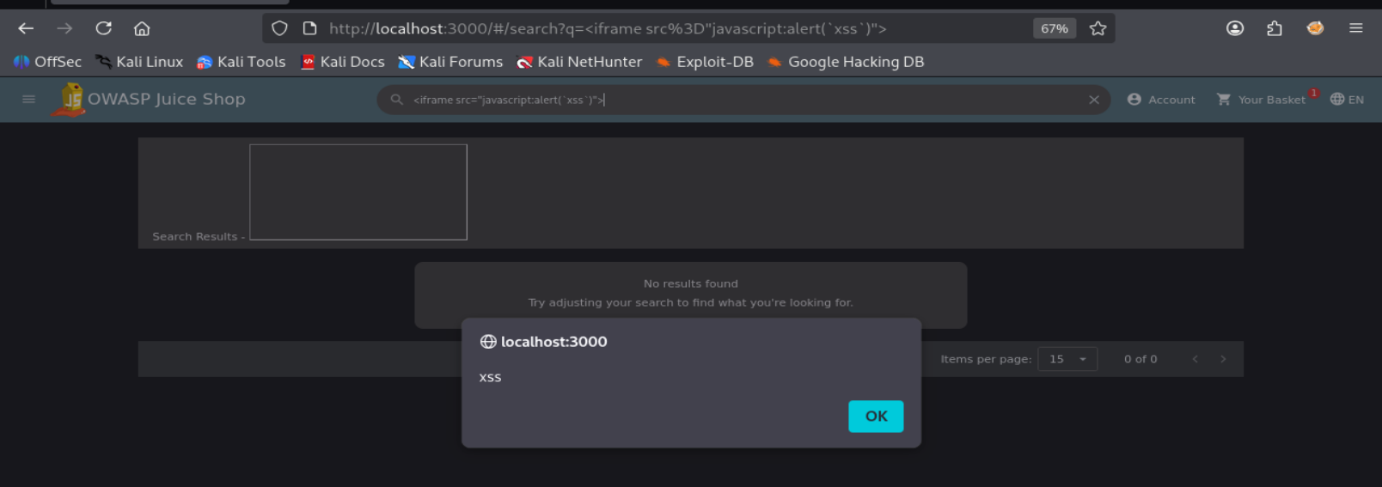
Evidence file: Evidence/EV-02-DOM-XSS-Alert.png
EV-03 — Score Board showing the DOM XSS challenge as solved.
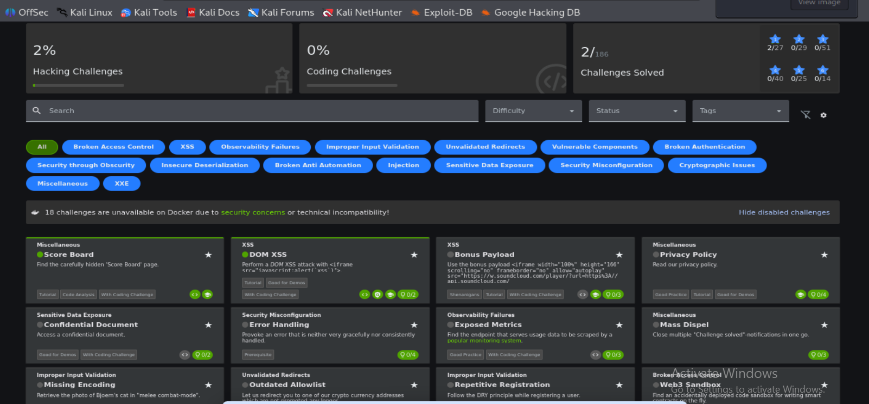
Evidence file: Evidence/EV-03-Scoreboard-DOM-XSS.png
EV-04 — Search results page and challenge context shown during Reflected XSS testing.
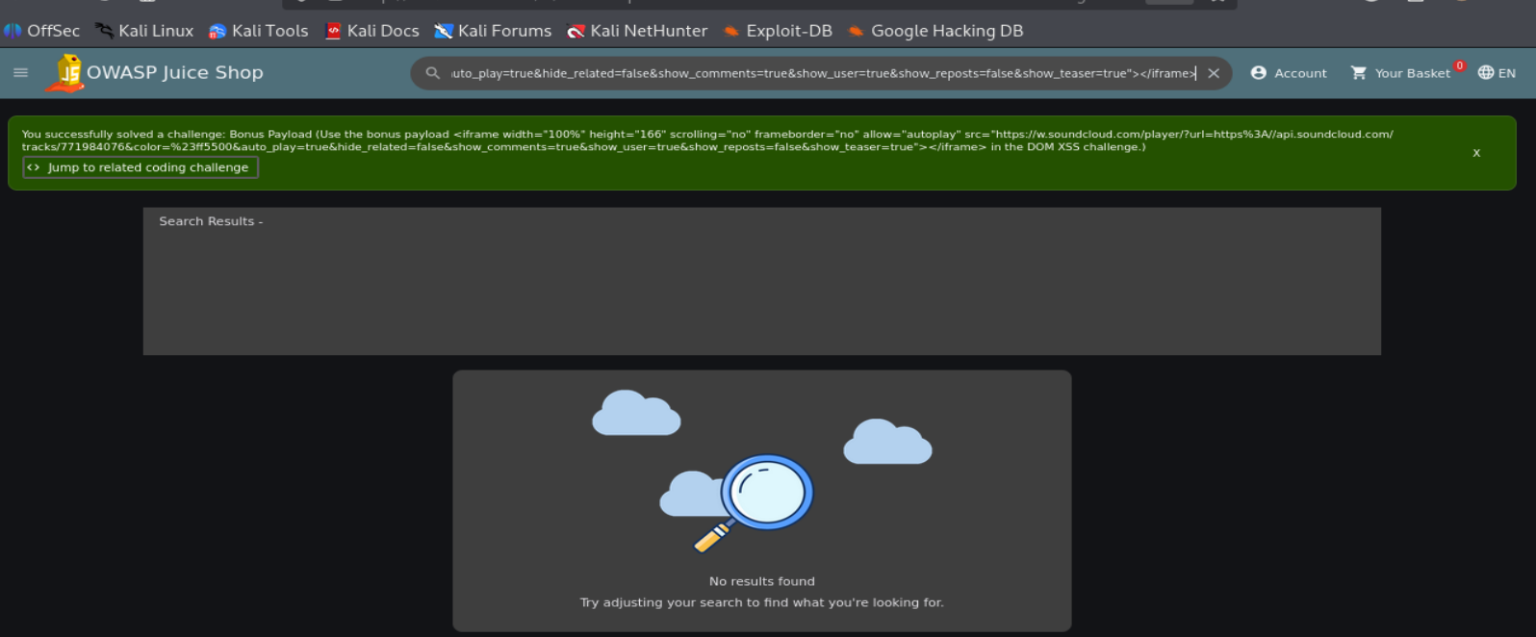
Evidence file: Evidence/EV-04-Reflected-XSS-Search-Page.png
EV-05 — Bonus Payload challenge card and its displayed challenge details.
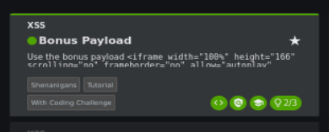
Evidence file: Evidence/EV-05-Bonus-Payload-Challenge.png
EV-06 — Score Board view showing the Reflected XSS challenge status.
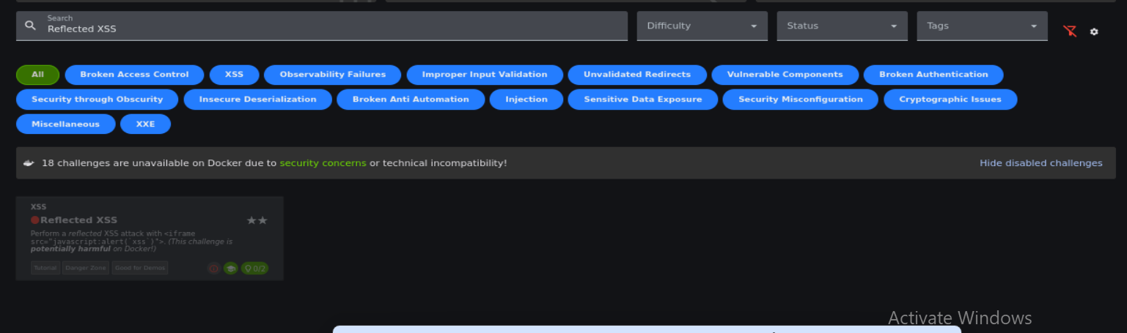
Evidence file: Evidence/EV-06-Reflected-XSS-Challenge-Status.png
EV-07 — JavaScript alert observed during the Reflected XSS investigation; challenge completion remains unverified.
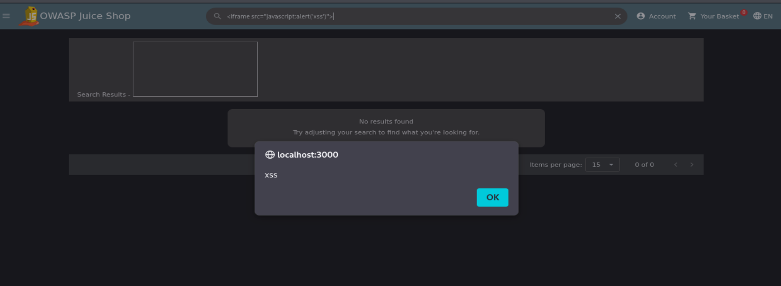
Evidence file: Evidence/EV-07-Reflected-XSS-Alert.png
EV-08 — Order confirmation page reached during preparation for Track Orders testing.
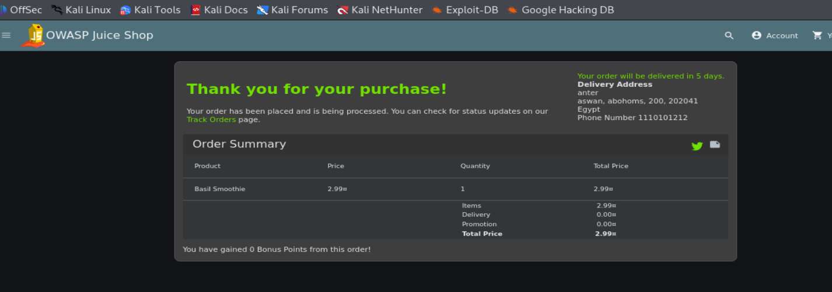
Evidence file: Evidence/EV-08-Order-Confirmation.png

